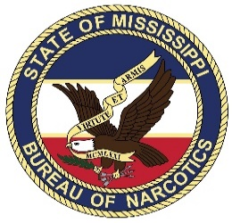
Mississippi Law Enforcement
Officers’ Training Academy

Narcotics Investigator Certification

Date for NIC 2025 class

NIC will provide advanced techniques, concepts, and methodologies for conducting narcotic investigations. The continuous, intensive learning process in conjunction with scenario-based learning will ensure that investigators have current training consistent with developing the knowledge, skills and abilities to perform as a narcotics investigator.

In this class, investigators will learn the needed skills to investigate both street level drug dealers and how to cultivate small investigations into large scale drug investigations of drug trafficking organizations (DTO). This class will require investigators to practice the techniques learned during class and complete certain tasks in between class sessions.

Topics:
- Management of Confidential Informants
- Controlled Purchase of Narcotics
- Surveillance
- Writing Search Warrants
- Operational Planning / Execution and Documentation of Search Warrants
- Seizure of Property and Seizure Warrants
- Case File Preparation
- Report Writing
- Introduction to Dark Web
- Current Drug Trends and Fentanyl
- Transition into Complex and Federal Investigations
NIC Course: $1,800 Does not include meals or lodging.
If you will be staying with us contact Barbara: bloyd@dps.ms.gov

This state certification will provide investigators working in the Mississippi criminal justice system with information to identify individuals distributing controlled substances and teach them how to successfully prosecute them.
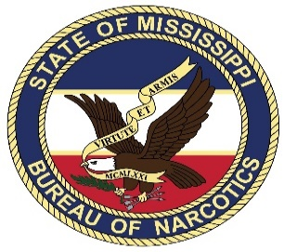

Mississippi Law Enforcement
Officers’ Training Academy

Narcotics Investigation Certification

To: NIC Coordinator
Date: ______________________
Subject: NIC Registration

I request that (Officer's name) ________________________________________ of the
(Agency name)____________________________________________________ be
enrolled in the Narcotics Investigator Certification. The candidate is a certified Law
Enforcement Officer by the State of Mississippi with ____________ years’ experience.
I realize that this course covers five (5) sessions, each session being one (1) week in
length each month and may take up to 6 months for completion. Every attempt will be made to
limit the officer from missing any sessions. If circumstances develop that my candidate cannot
attend, MLEOTA will be notified immediately so the slot may be filled by another candidate.

Requested by: (print name) ____________________________________________
Supervisor Title: _____________________________________________________
Supervisor signature: _________________________________________________
NIC/P- Officer candidate: ______________________________________________
Candidate's telephone number: _________________________________________
Candidate's work e-mail address: _______________________________________

Date received by NIC/P: __________________________
Date confirmed by NIC/P: _________________________
Scheduled for class #: ____________________________

Email: Karin Dear kadear@mbn.ms.gov for registration.

MLEOTA Office # 601-933-2101

