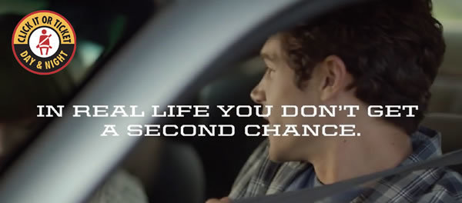
Welcome, Law Enforcement ... we need your help!
The National Seat Belt Enforcement Mobilization is May 20 to June 2, 2019
NHTSA has prepared this CIOT Products for Enforcement Action Kit (PEAK) to help you alert the public to prepare for maximum high-visibility seat belt enforcement.
Statistics show that passenger vehicle occupants are buckling up more during the day, but not enough at night. This mobilization is created to increase awareness 24-7, but a strong enforcement effort is urged between the nighttime hours of 6 p.m. and 5:59 a.m. due to the significant number of violators and fatal crashes during this time.
- Paid advertising will run from May 13 to June 2, 2019
- The enforcement period runs from May 20 until June 2, 2019
Click on the following links for more information:
PEAK materials
Mobilization campaign materials (banners, posters, flyers, et al)
Additional 2019 campaign materials coming soon:
- Updated infographics
- Campaign materials in Spanish
